STEEPLE BUMPSTEAD PARISH COUNCIL MEETING @ The Lecture Hall, Chapel Street, CB9 7DQ.
ON Thursday 9th December 2021 at 7.30pm
Chairman – Cllr Kerry Barnes
In Attendance – Cllr Rust, Cllr Hexter, Cllr Westrope, Cllr Borges, Cllr Mackenzie, Cllr Hill.
Also present -Cllr Garrod
Clerk – Mrs Julia Howard
Members of the public - None

M I N U T E S
21/302 | Welcome and to receive apologies for absence  Apologies from Cllr Swaby and Cllr Schwier.  The Chairman gave a COVID update, following recent advice. | Chairman
21/303 | Declarations of Interest – none | All
21/304 | To approve the minutes (previously circulated) of the Parish Council meeting held on 11th November 2021.  Cllr Hill proposed to accept these as a true record of the meeting, and Cllr Mackenzie seconded, all were in agreement. | Chairman
21/305 | Question Time – none | Chairman
21/306 | District Councillor’s Report (report circulated) – Invitation to Cllr Diana Garrod, Braintree District Council to address the meeting.  See the report for relevant road closures.  Local Plan section 2 (which is a detailed plan for Braintree District) public consultation commenced 6/12/21 and is open until 24/1/22.  Scam – people are being offered an Omicron Test, seemingly by the NHS – this is a scam and the NHS would not be asking for your card details.  Avian flu is on the rise again and measures are in place.  The full report is available on the Parish Council website each month.  A question was asked about the carer’s survey – which is being sent out in paper and by email | Chairman
21/307 | County Councillor’s Report – Cllr Schwier wasn’t present but has been circulating emails throughout the month | Chairman
21/308 | Casual Vacancy - Vacancy which will now be advertised for Co-option with an expiry of 31st January. | Chairman
21/309 | Welcome Packs– Cllr Hexter would like to create a welcome pack for newcomers to the village giving information about the village and resources within the village, where defibrillators are, what clubs are on and when. Cllr Mackenzie is putting together an informative guide to the Parish Council and these two things could be combined.  Cllr Hexter and Cllr Mackenzie to work on this and bring it back to the next meeting. | All
21/310 | Purchase of a VAS speed monitor – for placement where the 30mph speed limit is entering the village, on the Finchingfield road. The Parish Council have looked into some of the costs and options available, particularly looking at solar powered options. A mobile Speed Monitor is also an option.  Discussions followed and there was not enough interest to continue with this. | All
21/311 | Planning - Full details can be found on the Braintree District Council Planning Portal.  Item 1. Planning Applications – Received as at 2/12/21  21/03364/HH | 56 North Street, Steeple Bumpstead - Erection of single storey rear extension. – Recommended Approval  21/03329/TPOCON | 58 Lion Meadow Steeple Bumpstead | T1 ON SKETCH PLAN - OVERALL CROWN REDUCTION OF FRAXINUS EXCELSIOR BY APPROXIMATELY APPROX 4-5 METERS (40%) – No Objection  Late application; 21/03467/LBC for the Fox and Hounds, replacement windows – no objection | All
 | Item 2. Planning Applications – Decisions made by Delegated Powers as at 2/12/21 for note and ratification.  NONE  Item 3. Planning Applications – To note any decisions as at 02/12/21  21/03305/TPOCON | 15 Church Street - Notice of intent to carry out works to tree in a Conservation Area - Lime - diseased limbs to be removed down to living base. The tree is alive at the base and on some younger limbs so the four diseased limbs will be removed with the rest maintained. Status– pending consideration  21/03148/TPOCON - 28 North Street, Steeple Bumpstead – Notice of intent to carry out works to trees in a conservation area. Status – Pending Consideration  21/02888/HH - Schoolings, 20 Church Street, Steeple Bumpstead - Alterations to 21/01521/HH reduction in size of proposed new shed/workshop and relocation of existing shed adjacent to the new building. Status – Application Granted.  21/02819/TPOCON – 17 Water Lane, CB9 7DS. Notice of intent to carry out works to trees in a Conservation Area, tree reductions to 3 trees. Status -Pending Consideration  21/02541/FUL - Land At 16 Church Street, Church Street. Demolition of existing outbuilding and erection of 1No. 3-bedroom dwelling house. Alterations to existing site access. Status - Pending Consideration.  Item 4. Neighbourhood Plan (standing Item)  The PC has refunded the outstanding balance from the first grant and awaiting payment of the second grant.  The Chairman recently attended an online meeting with a consultant and talked about design codes and how they work. Design code is a service that is free and can be included in the Neighbourhood Plan. | Chairman
21/312 | Finance and Administration  Item 1. Accounts for Payment – to review and approve monthly accounts (receipts and payments) and for approval of monthly invoices and payments due.  Cllr Rust proposed to accept the report and list of payments, seconded by Cllr Mackenzie all were in agreement.  Item 2. Clerks report – for note and comment  Item 3. Budget Update – clerk is working on this and awaiting a return from Braintree District Council with a view to completing the budget statement and setting the Precept next month. | All
 | O T H E R I T E M S F O R D I S C U S S I O N
21/313 | Yellow Book Vacancy– The Yellow Book needs someone to handle the adverts for the magazine. Please contact the editor if you are interested or to find out more editor@sb-yellowbook.org | All
21/314 | Events Update  Item 1. Christmas / Festivities – The Christmas Tree lighting event went well and was warmly received. Cllr Mackenzie is still overseeing the tree and lights for the month. After the tree comes down the Parish Council will review the event and plan for Christmas 2022.  Chairman Cllr Barnes was approached to read the lesson at the Church service, on behalf of the Parish Council and will be doing this.  Item 2. Queens Jubilee – the update is due to be shared in January. | All
21/315 | Christmas Tree Collection – the Christmas tree recycling collection will be on 15th January 2022 at the Village Hall, 8am-8.30am
21/316 | Publication of Councillors Addresses – to share that Councillors are able to make an individual request directly to the Monitoring Officer for approval to remove their address from the Disclosable Pecuniary Interest Land category within the Register of Interests, which are published on the Councils Website.  If Councillors wish to do this, they will need to make an individual request directly to the Monitoring Officer.  Clerk to arrange a PO box address for the Parish Council.
21/317 | Information Sharing – Cllr Westrope – discussion regarding a recent complaint received by the PC. He has received a complaint about car parking and will respond as an individual rather than as the PC, Cllr Hexter – none, Cllr Hill – update re: patient participation group which has been on hold recently but will be starting up again soon, Cllr Peter Hill has been accepted onto the PPG and will update the PC regularly. Cllr Borges – allotments, one is encroaching onto the footpaths and needs checking, Cllr Rust will visit to determine whether the encroachment obstructs the footpath or is a boundary issue, Cllr Mackenzie – Village Hall footpath and hedge is on Village Hall land. The footpath needs clearing and maintaining. Camping Close trees need follow ups as per previous enquiries. Cllr Rust – still planning to go ahead with the Boxing Day walk. Posters to go up on the noticeboards, social media etc. | All
21/318 | Next Meeting – Thursday 13th January 2022, 7.30pm venue tbc (due to covid restrictions we will review the location of the meeting each month). | Note
21/319 | Meeting Close – meeting closed at 8.53pm  Signed by the Chairman ……………………….  Date …………………………………………………….

Action 1 | 21/306 Patrick.kilbty@essex.gov.uk is sending out the survey clerk check if we can share on social media | Clerk
Action 2 | 21/309 work on drafting a Welcome Pack and bring it back to the next meeting. | Cllr Hexter and Cllr Mackenzie
Action 3 | 21/315 clerk to advertise this on the website  Chairman to put on FB page. Clerk to inform the village hall | Chairman and Clerk
Action 4 | 21/316 arrange a PO box address for the Parish Council. | Clerk

Appendix a.
District Councillors report

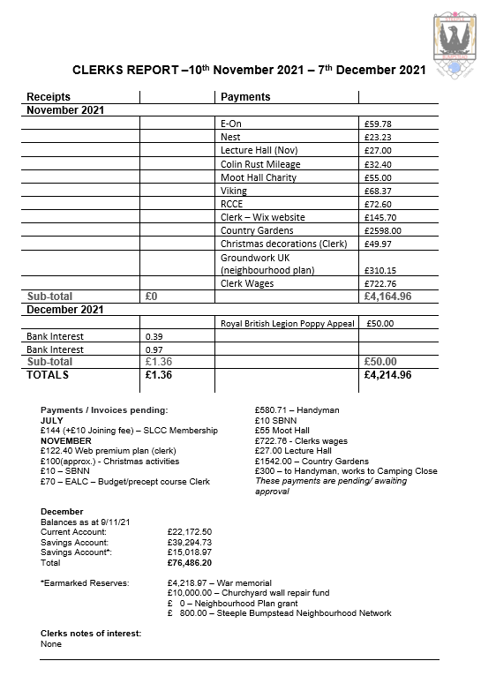

Appendix b. Clerks Report & Finance

