STEEPLE BUMPSTEAD PARISH COUNCIL Meeting @ The Moot Hall
on Thursday 8th December 2022 AT 7.30pm
Meeting Chair: Vice Chairman Cllr Hill.
In attendance: Cllr Borges, Cllr Mackenzie, Cllr Rust, Cllr Hexter.
Clerk: Mrs Julia Howard
Public: one

Draft MINUTES
22/176 Welcome and to receive apologies for absence Chairman
Apologies from Chairman Cllr Barnes, Cllr Denning, Cllr Westrope, Cllr Swaby, Cllr Schwier and Cllr Garrod.
22/177 Declarations of Interest - none Information
22/178 To approve the minutes (previously circulated) of the Parish Council meeting held in November 2022. Cllr Mackenzie proposed to accept the minutes as a true record, Cllr Rust seconded all voted in agreement.
22/179 Question Time Public Participation Session - one member of the public attended to speak about flooding issues in Maltings Lane. The flooding hasn’t encroached the properties, but does block them in (or out) which is a huge issue if there were any emergencies. There is a drain at the end of the Endway/ top of Maltings Lane (by Lower house farm) which is blocked with mud and has been for some time. It is on the ECC portal but not been attended to. The water stays on the ground for several days after the flooding in the village has gone. The PC will consider the points raised and respond in writing to the parishioner, however due to the festive period there will be a slight delay.
22/180 Invitation to Cllr Peter Schwier, Essex County Council and Cllr Diana Garrod, Braintree District Council – none. Apologies received from both Councillors.
22/181 Christmas Tree – our thanks to our Sponsors, The Bauble Barn, Jarvis Electrical, Gino’s Pizza and AKS, Rev Theresa Lowe for providing a refreshments stall and the Moot Hall for hosting. A big thank you to everyone involved and those who attended from the whole community.
22/182 Boxing Day Walk - 11am on Boxing Day, meeting at the village hall. Flyers will be up, and it’s in the Yellow Book and will be on social media too. Volunteer Marshalls are sought after, if anyone is interested in helping, please contact Cllr Colin Rust.
22/183 Planning Applications
New -
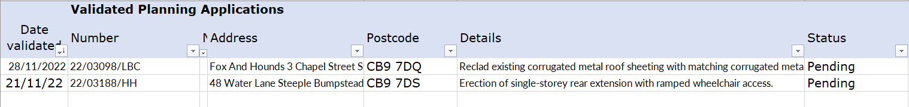
22/03188/HH 48 water lane – okay, 22/03098/LBC fox and hounds – okay. 22/03162/COUPA Maltings Poultry farm, change of use –objection submitted by the PC. 22/03202/PLD 41 The Endway – okay.
22/03173/SCR Rowley hill solar farm – pre-consultation – concerns over power supply capabilities wouldn’t want to see
new power lines / telegraph poles. Would like to know whether new power lines will be buried. There should have
been a public consultation in person and a longer consultation period for the written responses, which were not easy to
use, not user friendly and looked like junk mail – small white writing on blue background. Clerk to submit a response on
the LanPro consultation online tonight.

Decisions -
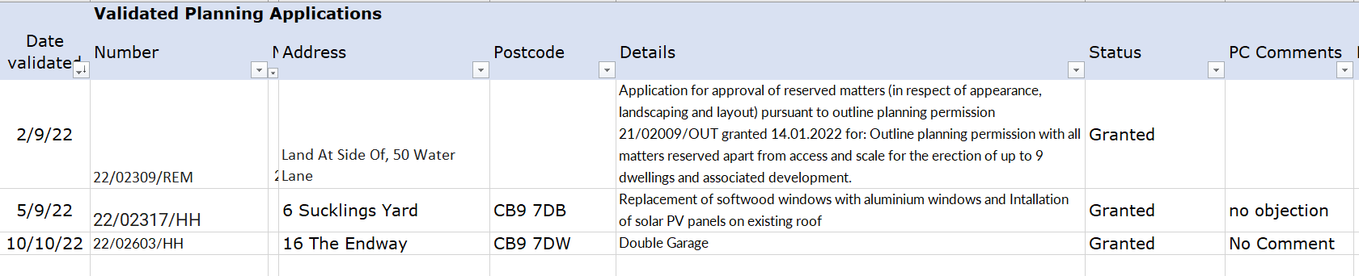
22/184 Neighbourhood Plan, No further update Information
22/185 Financial Matters - To note receipts and approve upcoming payments Appendix a
Cllr Borges proposed to approve the financial report, Cllr Rush seconded and all voted in agreement
22/186 Budget Setting – for year 2023/24 Decision
The Budget group have gone through every line of the budget document and it was circulated to all Councillors for review. There will be a zero increase in the precept. The figure will remain at £43,409 for the third year. Cllr Borges proposed to accept the budget, Cllr Rust seconded and all voted in favour.
22/187 Adoption of the draft Grant Awarding Policy – A new policy was drafted, Cllr Hexter proposed to adopt the policy and Cllr Hill seconded, all were in agreement
22/188 Clerks Report – The actions list was shared. See appendix b.
Julia is now a CiLCA qualified Clerk, having passed the year long course recently.
22/189 Open Spaces -updates from open spaces groups Information
Item 1. Village Tree Survey – Caroline Hall, has been booked to do the tree survey and is
looking to be done on a date in January tbc. Chairman Cllr Barnes and Cllr Mackenzie will arrange to meet with her when she arrives.
Item 2. New Trees – with thanks to the environmental group 23 trees (from the Queen’s
canopy) were planted and are being watered. 7 more trees will be planted on the Camping Close in January with preschool’s assistance along with the larger Oak tree.
Item 3. Bumpstead Brook – update on the condition / excess growth / flood risk – this ties in
with the question from the parishioner earlier this evening and Cllr Hexter has an ongoing action to address the condition of the Brook. An update will be requested again in January.
OTHER ITEMS FOR DISCUSSION
22/190 S106 – Village regeneration – a new email address has been set up for this, so that we can gather communication from the wider village when we are ready to start looking at repairing or replacing equipment. The PC has approx. £4k due which is expected to go on the slide and maybe a replacement notice board – subject to getting quotes. The larger amount will want input from parishioners and so when we get to that point there is an email address set up to gather views, or to do surveys from it is office.steeplebumpstead.pc@gmail.com It is currently live but not monitored
22/191 Christmas Tree collection – recycle your real Christmas trees from the Village Hall, Saturday 14th January, 8-8.30am. The PC’s Christmas Working group plan to get together on Friday 13th to remove SBPC’s tree decorations to go back to the children of the village.
22/192 Information Sharing – Cllr Hexter – Library update, furniture has been offered to update the library, hopes to open soon. Cllr Rust – has cut and removed another fallen tree by the bowls club, Cllr Mackenzie – there was a minor accident at the Haverhill junction road, should have a give way or stop sign there. Cllr Hill – there is an interested party in restarting a nursery.
22/193 Next meeting – 12th January.
22/194 Meeting Close – 20.45
Actions
Item | Details | Who
22/179 | Council to respond in writing to member of the public | Chairman / Clerk
22/181 | Council to write letter of thanks to donors | Clerk
22/187 | Add Grant awarding policy to the website | Clerk

Appendix a. Finance report.
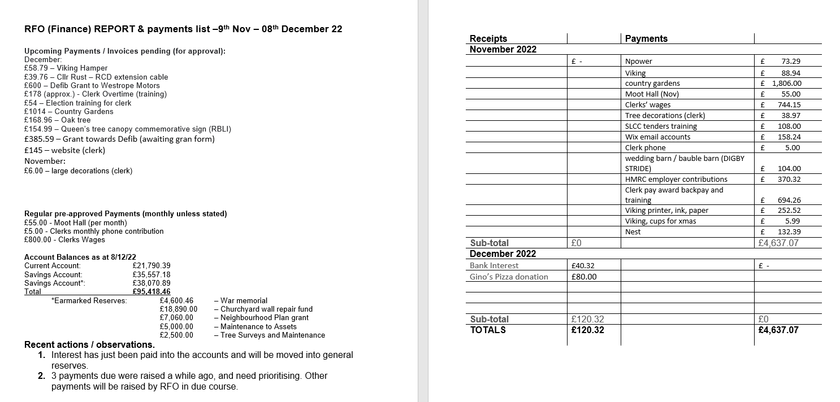

Appendix B, Clerks report, update on actions

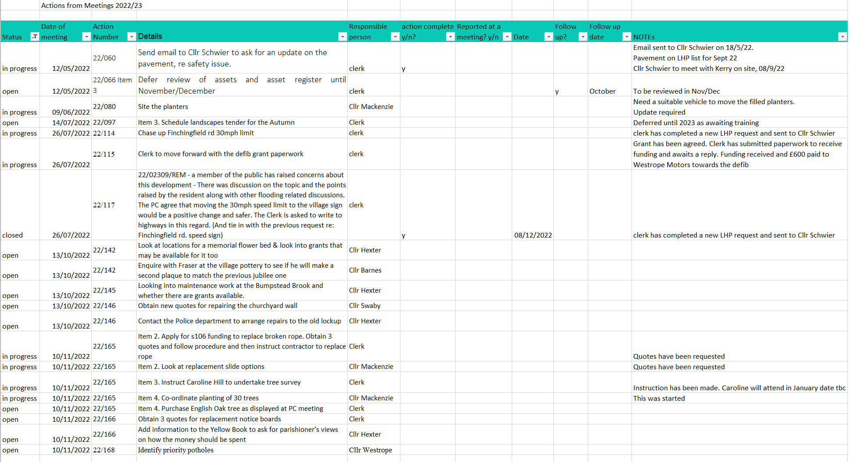

Signed By Chairman………………………………
Date …………………………………………………….

