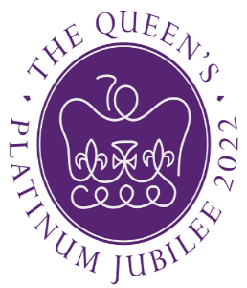
Steeple Bumpstead Celebrates Her Majesty the Queens Platinum Jubilee
In 2022, Her Majesty the Queen will become the first British Monarch to celebrate a Platinum Jubilee after 70 years of service.
This is your Invitation to join in the celebrations, have a bit of fun and enter our two competitions.
Best Decorated House
Turn the village into a sea of Red, White, and Blue, get the Flags and Bunting out and show your support to HM queen and decorate the outside of your house
The house considered by our judges to be the best dressed will win a special prize.
Scarecrow Competition
Make your own scarecrow and place in your garden, be as imaginative as you like Her Majesty will enjoy your humour and imagination.
The house considered by our judges to be the best Scarecrow will win a special prize.
Full details of the competition can be found on the Parish Council website www.steeplebumpstead-pc.org
Or on the Parish Council Facebook Page.
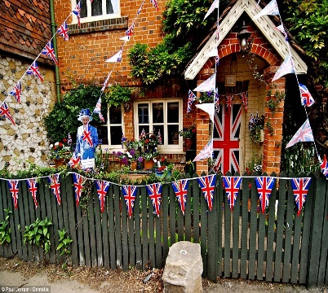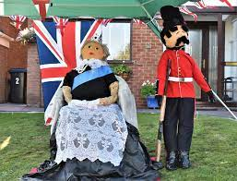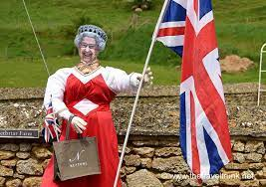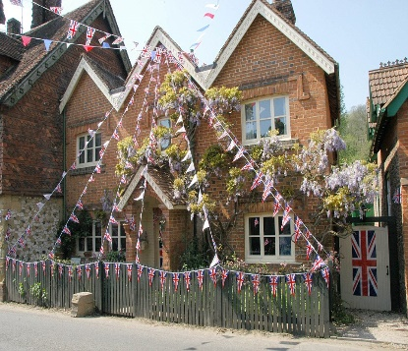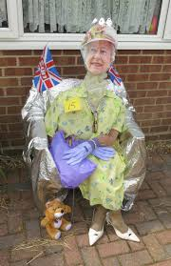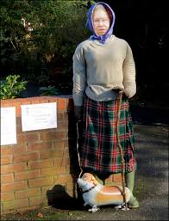
Your chance to take part in the celebrations. If you would like to enter your house into the Scarecrow competition, please email hmplatinumsteeplebumpstead@gmail.com, full details will be sent to you. Come on join in the fun.
The competitions start on Monday May 30th, 2022, and will finish Sunday 5th June 2022.
Best Decorated House

Decorate the outside of your house in RED, White and Blue Bunting and Flags
Be as adventurous as you like and decorate your front garden as much as you like.

THE BEST DRESSED HOUSE COMPETITION will be judged on Saturday 4th June 2022 as part of the village Morning Cup of Tea Trail.
A trail with guide map of all decorated houses will be available and residents will be invited to walk the trail on Saturday morning and say hello as you drink your cup of tea on the lawn, this is a community competition and let’s show HM the Queen that we are delighted to join in the celebrations of her Platinum Jubilee and Steeple Bumpstead loud and proud says” Cheers Ma’am”

Scarecrow Competition
THE BEST SCARECROW COMPETITION will be judged on Saturday 4th June 2022 as part of the Village Morning Cup of Tea Trail.
Using Straw or whatever you have create your doll of HM the Queen and be as adventurous as you like, not just the Queen her family, her dogs, plenty of humour, remember this is a happy time and we all know HM the Queen likes a good laugh.
A trail with guide map of all decorated houses will be available and residents will be invited to walk the trail on Saturday morning and say hello as you drink your cup of tea on the lawn, this is a community competition and let’s show HM the Queen that we are delighted to join in the celebrations of her Platinum Jubilee and Steeple Bumpstead shouts loud and proud says” Cheers Ma’am”

So Come on Steeple Bumpstead, this is an incredibly special time for our country. Her Majesty the Queen has given to our country 70 years of wonderful service and its time for us to say THANK YOU.

Please enter your property into the competition by registering at the email address hmplatinumsteeplebumpstead@gmail.com

