STEEPLE BUMPSTEAD PARISH COUNCIL MEETING
ON Thursday 10th March 2022 at 7.30pm

Chairman: Kerry Barnes
In attendance: Cllr Hexter, Cllr Swaby, Cllr Hill, Cllr Westrope, Cllr Borges, Cllr Rust and Cllr Denning
Also present: Cllr Garrod
Clerk: Julia Howard
Members of the public: none

M I N U T E S
22/038 | Welcome and to receive apologies for absence – The chairman opened the meeting with an acknowledgement of the Ukraine situation. Apologies from Cllr Schwier and Cllr Mackenzie | Chairman
22/039 | Co-Option of Parish Councillor – the third candidate was interviewed and the personnel working group propose to put forward Rebecca Denning to be co-opted, seconded by Cllr Hill. All were in agreement. Cllr Denning signed her acceptance of office at the meeting. | Decision
22/040 | Declarations of Interest -none | Decision
22/041 | To approve the minutes (previously circulated) of the Parish Council meeting held on 10th February 2022.  Cllr Hill proposed they are a true record of the meeting, Cllr Rust seconded, all were in agreement. | Decision
22/042 | Question Time - none | Information
22/043 | Invitation to Cllr Peter Schwier, Essex County Council and Cllr Diana Garrod, Braintree District Council – a report from Cllr Garrod was circulated and is on the website. Cllr Garrod explained more fully about the boundary commission review and advised that the survey is still open. It is quite complex for Steeple Bumpstead sitting on the border of 3 counties. Cllr Hill asked whether we could get an update on the road closure of Haverhill Road, from Bumpstead through to Haverhill due to broadband works; these works have been delayed to the 22nd with the road being closed for 7 days – unfortunately there is nothing we can do about this. | Information
22/044 | Queens Platinum Jubilee 2nd – 5th June 2022 final update by Cllr Mackenzie – see appendix 1 the chairman provided an update, there was a planning meeting on Monday evening which was well attended, minutes will be shared. We will also share a schedule of events.  The PC have made a decision, that if we can get a grant to fund it, the PC will get a Jubilee Beacon, and place it on the camping close. However, if the grant isn’t awarded, the bonfire at Freezes barn will be used again.  The Parish Council has been looking at purchasing a memento type gift, the most popular choice was a packet of official jubilee seeds, to be delivered to each household along with the Yellow book. We would need approx. 725 packets of seeds; the alternative is to have seeds just for the children of the village. Discussions followed. Cllr Swaby then proposed to deliver a packet of seeds to each household, at the purchase cost of approx. £750, and for a virement from general savings for this spend under section 137, Cllr Hexter seconded and all were in agreement. | Decision
22/045 | Christmas Tree event 2022 –the review of Christmas tree event 2021 was shared, there was a lot of information and the PC are keen to expand on the successes of last year. The PC plans to commence a working party for 2022 in the new financial year. | Decision
22/046 | Planning - Full details can be found on the Braintree District Council Planning Portal. Cllr Borges has created a spreadsheet which we will use for future meetings, and will be available on the Council’s website.  Item 1. Planning Applications – Received as at 3/3/22  22/00335/TPOCON | Notice of intent to carry out works to trees in a Conservation Area - T1 ON SKETCH PLAN - ACER, OVERALL CROWN REDUCTION OF 1 METRE 30% and T2 ON SKETCH PLAN - ROWAN, OVERALL CROWN REDUCTION OF 2 METRES 30% | 64 Lion Meadow Steeple Bumpstead Essex CB9 7BY - no comment  22/00405/NMA | Non-Material Amendment to permission 21/00775/HH granted 26/04/2021 for: Erection of part single and part two storey rear extension. Amendment would allow for: - Change of external finish from facing brick to fibre cement cladding - Addition of gable window and velux roof light to extended bedroom | 43 Churchfields Drive Steeple Bumpstead Essex CB9 7EU – for information only  21/01183/COUPA | Maltings Poultry Farm, Prior approval for the change of use of agricultural building to a dwellinghouse (Class C3), and for  associated operational development - Change of use to 5 No. residential dwellings. Sturmer Road Steeple Bumpstead CB9 7BS – notification of appeal 3285089  22/00458/HH | Erection of front porch | 56 North Street Steeple Bumpstead Essex CB9 7DP – recommend approval  Item 2. Planning Applications – To note any decisions as at 3/3/22  22/00028/TPOCON - 15 Chapel Street- Notice of intent to carry out works to tree in a Conservation Area - Common Lime (T1) - Re-pollard back to previous points. Currently about 2-3m epicormic growth, diameter of growth suggests preferable time to restart cycle. – Granted  22/00105/TPOCON 16 Church Street, CB9 7DG. Notice of intent to carry out works to a tree in a Conservation Area - Remove a Sycamore tree and replace with an Oak tree – Pending Consideration  22/00238/TPOCON- 62 Lion Meadow Steeple Bumpstead Essex CB9 7BY. Notice of intent to carry out work to trees in a Conservation Area - T1 ON SKETCH PLAN - FRAXINUS EXCELSIOR OVERALL CROWN REDUCTION OF 30%, T2 ON SKETCH PLAN - LEYLANDII FELL TO GROUND LEVEL, T3 ON SKETCH PLAN - LEYLANDII FELL TO GROUND LEVEL, T4 ON SKETCH PLAN - DEAD ULMUS FELL TO GROUND LEVEL - Pending Consideration | Information
 | 21/03607/FUL - Maltings House, Sturmer Road, Steeple Bumpstead, Demolition of dwelling and outbuildings and construction of a replacement dwelling and cart lodge. Application Refused  21/03612/FUL - Maltings House Sturmer Road Steeple Bumpstead Essex CB9 7BS, Demolition of dwelling and outbuildings and construction of a replacement dwelling and garage. Status -Pending Decision  21/02819/TPOCON – 17 Water Lane, CB9 7DS. Notice of intent to carry out works to trees in a Conservation Area, tree reductions to 3 trees. Application Granted  Item 4. Neighbourhood Plan (standing Item) - A draft plan has been sent in and the consultant has agreed to start work on the first 2 tasks. There is also a free design consultant who Cllr Borges will be meeting with shortly. This should also have a focus on the street scene of the conservation area. | Information
22/047 | Finance and Administration  Item 1. Accounts for Payment (circulated) – see appendix 2  The accounts were shared along with a list of payments to be paid in the coming month.  Cllr Swaby raised concerns over paying for the work to 6/7 trees by the top car park of the camping close, a discussion followed and the Council have asked the clerk to put this on hold for the time being. The clerk advised that this was the wrong time to be making these decisions and that it was an agenda item for approval last month which was the right time for discussing and making decisions. Chairman Cllr Barnes advised that the PC will still put it on hold and visit to review the trees further due to concerns about setting a precedent.  All other payments were agreed. Cllr Hill proposed to pay all upcoming payments with the exception of the Treeworx entry, this was seconded by Cllr Swaby and the majority in agreement, Cllr Westrope abstained from voting.  Item 2. Policies for adoption – Equality and Diversity Policy – policy was adopted as recommended by the Policies working group. Cllr Hexter proposed adoption, seconded by Cllr Barnes, all were in agreement.  Item 3. Budget update – see appendix 3 the Clerk shared the current status of the budget, thus far. Along with the 3rd quarter bank reconciliation which had been handed to Cllr Hill for audit.  It is noted that the council tax bills have come through with significant increases, but as the PC didn’t increase the precept there is a tiny 0.2% increase there  Item 4. Approve internal auditor - The Council are happy to use Simpson accountancy again. | Decision  Decision  Information  Decision
 | O T H E R I T E M S F O R D I S C U S S I O N
22/048 | Yellow Book Deadline 14th March – Cllr Hexter discussed items to include. | Information
22/049 | Dog Fouling – there has been an increase in fouling around the village, in particular near the school. The dog warden has been informed and dog owners are reminded of their obligation to clear up after their pets. | Information
22/050 | Claywall Bridge – damage to verge and debris on pavement, due to the Lime tree coming down in the wind. This has been reported to UKPN for damage to the verge and leaving a large cable on site, and to Essex Highways for the damage to the pavement. | Information
22/051 | Information Sharing – Cllr Westrope – none, Cllr Hexter-none, Cllr Hill-none, Cllr Borges-there are 4 days left for registering for solar panels (done as a reverse auction), Cllr Denning-none, Cllr Swaby-matting has been put round by the cemetery layby, the football shed has been cleared out, Cllr Rust-none, Chairman-none | Information
22/052 | Next Meeting – The Annual Parish meeting will be on Wednesday 20th April 2022, 7.30pm at the Lecture Hall.  The Annual meeting of the Parish Council will be on Thursday 12th May, The Moot Hall. | Note
22/053 | Meeting Close – 21.27pm | Note

Signed by the Chairman ……………………….
Date …………………………………

Actions:

Action 1 | 22/039 – clerk to send welcome pack to Cllr Denning | Clerk
Action 2 | 22/046 item 4 – request an invoice to be sent to the clerk | Cllr Borges
Action 3 | 22/047 – clerk to ask contractor to pause works to trees | Clerk
Action 4 | 22/047 item 2 – clerk to add new policy to website | Clerk
Action 5 | 22/048 article for yellow book to be sent to clerk | Cllr Hexter

Appendix 1

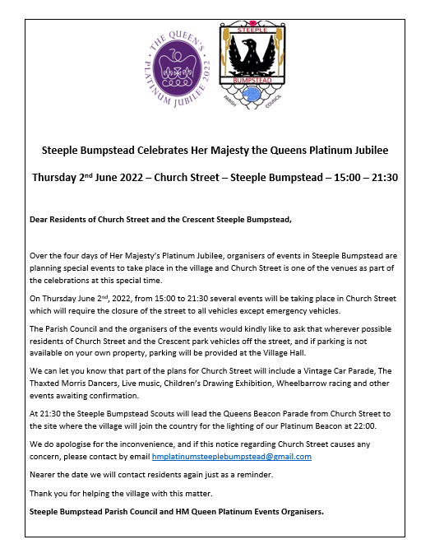

Appendix 2

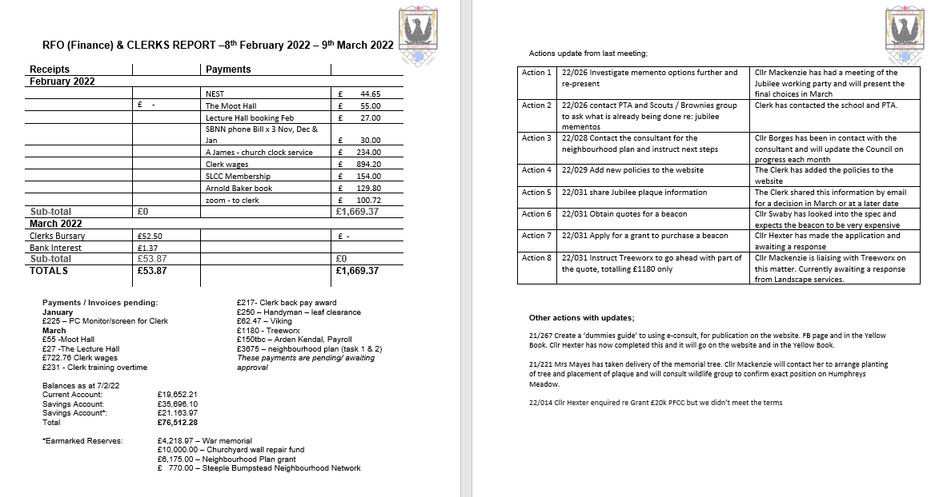

Appendix 3
