**STEEPLE BUMPSTEAD PARISH COUNCIL Meeting @ The Moot Hall**

**on Thursday 13th October 2022 AT 7.30pm**

**Chairman:** Cllr Kerry Barnes

**In attendance:** Cllr Jon Borges, Cllr Roy Swaby and Cllr Alice Hexter

**Clerk:** Mrs Julia Howard

**Members of the Public:** None

**MINUTES**

**22/132 Welcome and to receive apologies for absence Chairman**

Apologies from Cllr Garrod, Cllr Hill, Cllr Denning, Cllr Rust, Cllr Mackenzie and Cllr Westrope.

**22/133 Declarations of Interest -** Cllr Hexter, 22/138 non pecuniary interest and would like

to comment.  **Information**

**22/134 To approve the minutes** (previously circulated) **Decision**

Cllr Swaby proposed that they are a true record of the meeting, Cllr Borges seconded, all voted in agreement.

**22/135 Question Time** - none **Information**

**22/136 Invitation to Cllr Peter Schwier, Essex County Council and Information**

**Cllr Diana Garrod, Braintree District Council** to address the meeting.

Cllr Barnes summarised the report from Cllr Garrod, which is on the PC’s website and noticeboards.

**22/137 Remembrance Parade –** to discuss the arrangements and purchase of poppy wreath

and whether to purchase a silent soldier. **Decision**

Cllr Westrope is happy to arrange the wreath and crosses as usual, it has been agreed that the war

memorial fund can’t be used for the silent soldiers. Therefore, if the PC would like to purchase a

silent soldier it would need to be purchased from general reserved.

Cllr Swaby proposed that a Silent Soldier is purchased for ~£175 this year out of savings and put at

the bottom of Queen Edith drive, Cllr Hexter seconded, and it was agreed. The clerk is to make a

virement from general savings into the current account in order to make the purchase.

**22/138 Planning Applications**

**New -**



22/02486/TPOCON - No objection, 22/02603/HH - No comment, 22/02515 - The PC comment that although there is no objection to the works, the Council would like to see that any replacement windows remain in keeping with the age of the building and the conservation area. We note it is in the conservation area and it is unclear what the windows will be made from, we would hope they would be timber and thus in keeping with the area.

**Decisions -** 22/02111/HH – Folly farm – Granted,

22/02091/TPOCON – 30 North St. – Granted

22/02047/TPOCON – Ffytches, 1 Churchfields walk - Granted

**22/139 Neighbourhood development plan,** to receive an update **Information**

Wynne-Williams have been instructed to do the Landscape assessment and ensure the protected views across the village. The RCCE have been asked to prepare to do the residents survey.We will also need to instruct a printer’s firm.

**22/140 Financial Matters (appendix a) -** To note receipts and approve upcoming payments **Decision** The accounts now hold over £100k and therefore the council should consider an investment strategy**.** Cllr Swaby proposed to approve the payments, Cllr Hexter seconded all were in agreement.

**Budget Update (appendix b) –** The status of this year’s budget (mid-year) is looking as expected. There were discussions regarding the electricity costs and the earmarked funds.

**Asset register –** review of the asset register is due; the clerk has proposed that we

arrange an online asset management system and the clerk is looking into. It is a work in progress.

**22/141 Clerks Report (appendix c)-** To note updated actions and update outstanding items **Information** Note that there have been overflowing sewers at Humphries meadows, blockage due to wipes etc. Residents are asked to take care with what is flushed.

**22/142 Open Spaces** -updates from open spaces groups **Information & Decision**

**Item 1. In memorandum of Queen Elizabeth II -** last month the open spaces

working group were to look options / locations for planting a more mature tree and report back. The proposed location is in the corner by the village hall and play area. Cllr Hexter suggested a flowerbed may be a nice option and will look into this for the next meeting, Cllr Hexter will look into applying for a grant once agreed. Cllr Barnes will speak to Fraser about an additional plaque to match the previous on.

**Item 2. ROSPA report action plan** – to agree next actions

The ramp grips were tightened by the handyman, the damaged rope wall has been reported to Mortimer and we’ve asked for a quote to repair/ replace it. The clerk has emailed the s106 team at BDC but no response as yet, to see what funding we have available to renew and/or repair equipment.

Cllr Hexter noticed that the woodchip needs raking by the roundabout, this should be done every week by the handyman. Clerk do a sign for broken rope, Cllr Hexter to send photo of the swing, may need to put out of action.

**Item 3. Village Tree Survey –** to provide an update

Charges to inspect the trees, attaching numbered tags for identification purposes and provide a written condition report pertaining to the tree species, location/zone, height, diameter, age class, physiological and structural condition with recommendations for any necessary works with timings, and identifying pertinent surrounding features are as follows**:** Shane Lanigan has quoted to do this at the Camping Close for £240 + a charge per tree depending on size. And again, at Humphries Meadow for £240 + a charge per tree. Clerk to go back to Shane and ask for a closed / capped quote and look at getting another quote for comparison.

Our trees from the Woodland trust will arrive sometime between 31st October and end of November

**Item 4. Flower Planters** – these are yet to be placed. One will be used for the

Christmas tree, Cllr Swaby suggested putting a tree tube in the planter to secure the Christmas tree each year. Cllr Swaby is liaising with companies re: donations and will speak to Cllr Mackenzie and bring it to the next meeting

**22/143 Councillor Training** – training on code of conduct and finances update **Information**

Clerk is going to a BDC meeting where we will be discussing the new code of conduct and rolling it out to our Councillors.

**OTHER ITEMS FOR DISCUSSION**

**22/144 Pizza van** – Kate from the Fox and Hounds pub has approached the Parish Council

regarding having Gino Vines mobile pizza van attend each Friday evening and park by the pub. The

PC don’t have jurisdiction over this, and providing the relevant licenses are in place and neighbours

consulted with the PC would support Kate in this new partnership and wish her every success.

**22/145 Grants** – An update on the CIF grant progress is still pending.

Dedham Vale has a large grant which is available, and Cllr Hexter is concerned with the growth in the

Bumpstead brook, Cllr Hexter is to speak to Cllr Mackenzie regarding approaching the Environment

Agency following up from concerns raised by him about the Bumpstead Brook.

**22/146 Churchyard Wall Update –** The working group has not met since before 2020.

There is now £18k in the churchyard wall earmarked account, which the PC will look to move into

another account, following some investment advice. Cllr Swaby will look into what works are

required and obtain new quotes.

The police lock up next to the church wall needs repair. Cllr Hexter will look into this and report

back.

**22/147 Highways Survey update –** Cllr Ian Mackenzie and Cllr Ian Westrope to update.

This hasn’t been done yet.

**22/148 Flooding Update** – Update on flooding in the village / Bumpstead Brook, covered

above in 22/145

**22/149 Solar farm proposal –** the PC have been approached regarding a possible future

proposal for a solar farm on the boundary of the village and have a meeting arranged in the Moot

Hall on Thursday 3rd November at 7pm. Please advise the clerk if you intend to come.

**22/150 Information Sharing –**we asked for our top 3 policing priorities, which were agreed as Speeding vehicles, loitering/possible drug use and abandoned / badly parked cars and fed back to the Neighbourhood policing team. The King’s Coronation is now planned for 6/5/23 which is a Saturday. Chairman – BALC meeting next Wednesday in Witham, addressed by police and crime commission would anyone else like to attend, let Kerry know. Cllr Borges - none, Cllr Swaby – none, Cllr Hexter – library still waiting opening, consideration over whether it could be a ‘warm space’.

**22/151 Next meeting - 10th November**

**22/152 Meeting Close – 21.34pm**

Actions

|  |  |  |
| --- | --- | --- |
| Item | Details | Who |
| 22/137 | Purchase silent solider and make a virement from general reserves to fund this | Clerk |
| 22/142 | Look at locations for a memorial flower bed & look into grants that may be available for it too | Cllr Hexter |
| 22/142 | Enquire with Fraser at the village pottery to see if he will make a second plaque to match the previous jubilee one | Cllr Barnes |
| 22/142 | Item 2. Do a sign to alert parents of the damaged items at the park | Clerk |
| 22/142 | Circulate a photo of the damaged swing, determine whether it needs to be removed | Cllr Hexter |
| 22/142 | Item 3. Obtain additional tree survey quotes | Clerk |
| 22/145 | Looking into maintenance work at the Bumpstead Brook and whether there are grants available. | Cllr Hexter |
| 22/146 | Obtain new quotes for repairing the churchyard wall | Cllr Swaby |
| 22/146 | Contact the Police department to arrange repairs to the old lockup | Cllr Hexter |

Signed By Chairman………………………………

Date …………………………………………………….

Appendix a. financial report Appendix b. Budget update (mid-year)

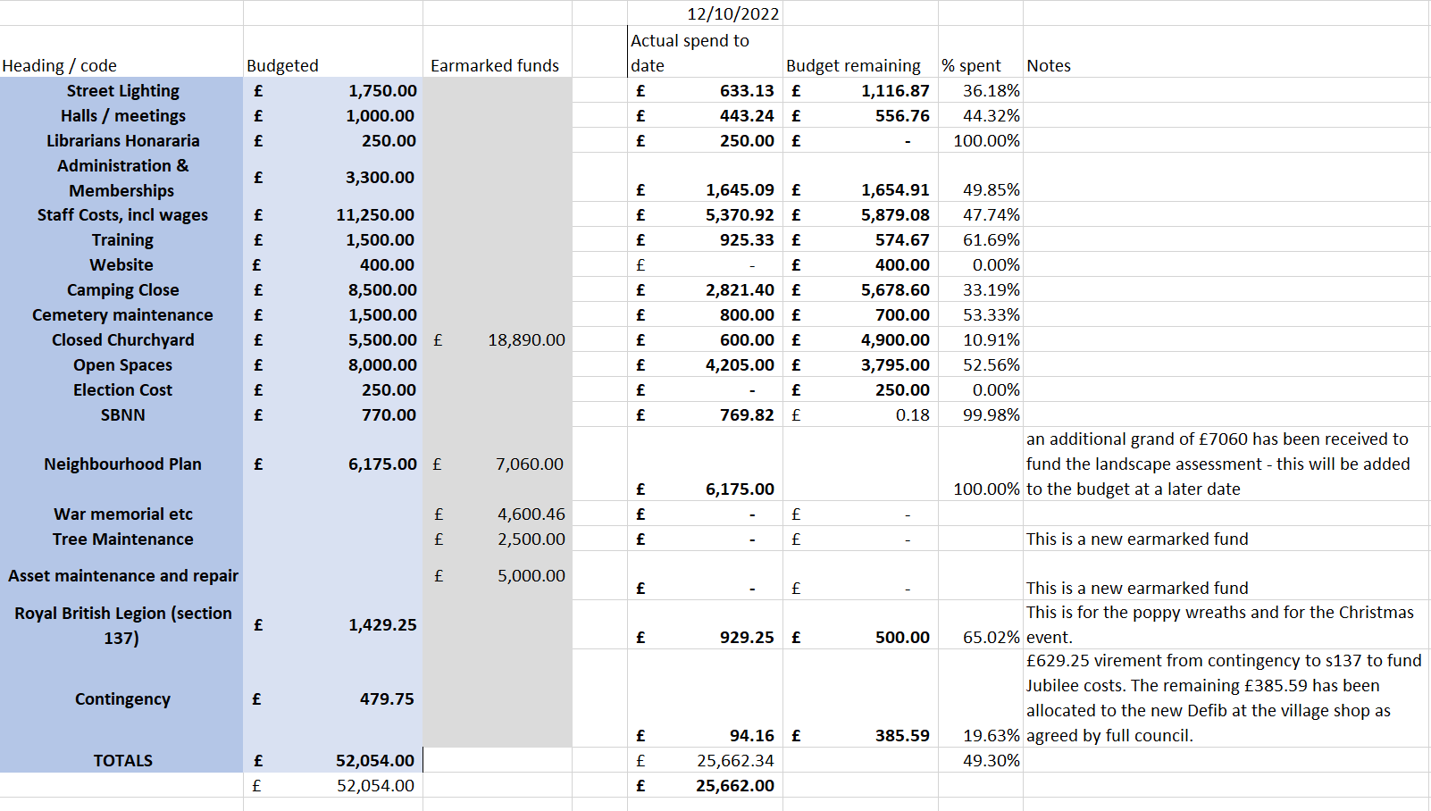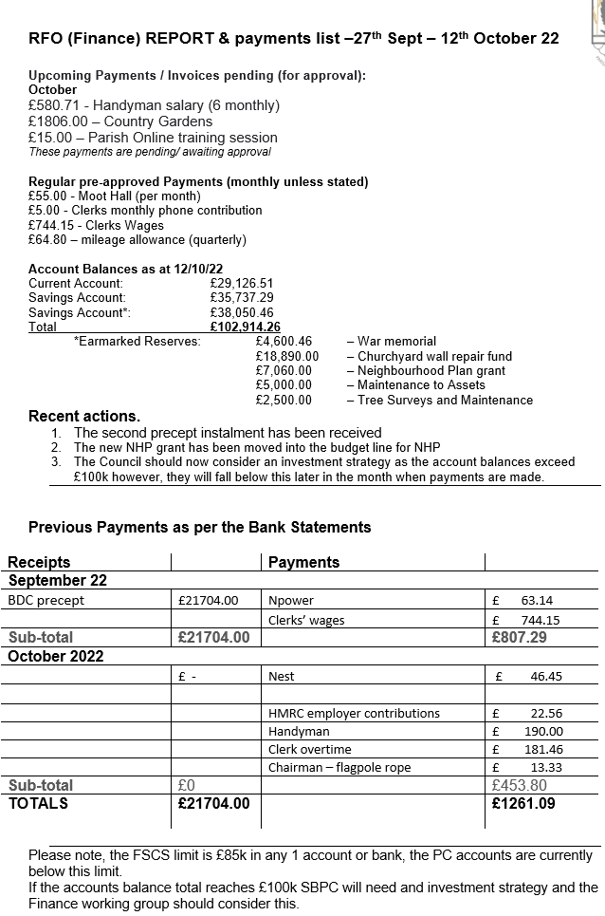

Appendix c. Clerks report / Actions updated

